Flamatt, October 2018

Press Release
CONTRAFLAM VETROGARD Blast: Highly effective protection from fire and explosions
Multifunctional and Uncompromisingly Safe
The world is changing – and the requirements for fire-resistant and high-security glazing will grow increasingly more complex in the future. Vetrotech Saint-Gobain continuously invests in targeted research and development to expand its range of products and satisfy people's needs for comprehensive protection with precision, today and in the future. As a result, with CONTRAFLAM VETROGARD Blast, Vetrotech presents a high-security glass that protects equally effectively against fire and explosions.
Many different buildings are exposed to a high risk of hazard due to their function or location. This can be explained, on the one hand, by the ongoing latent threat level even in Europe and, on the other hand, by increasing urbanisation and the accompanying redensification of metropolitan areas. The latter results in buildings being built closer to each other and to traffic arteries – be that routes for cars, public transportation, or the ever-expanding rail traffic. This means that governmental buildings, train stations and airports must be protected by high-security glass against various forms of dangers. Additionally, there is the protection of new, public spaces with large numbers of people – so-called third places – that will in future become modular sites for various and even new functions. For this, it is necessary to develop new security concepts, products and solutions. Companies such as Vetrotech realise that the demand for "invisible" security-glass and fire-protection solutions, (keyword: flashover), has already grown and will continue to. Here, discreet solutions are called for that not only guarantee all-encompassing safety and combine protective functions against a variety of dangers but also take into account the desire for architecture that is aesthetically sophisticated. And the requirements are becoming even more complex: the glass should not only protect against fire but against violent forces as well, such as break-ins (anti-panic), explosions and/or bombardment. In the field of facades, special coatings are also being deemed increasingly more frequently as a designated additional requirement.
Within this context, as a part of the Saint-Gobain stand at Glasstec 2018, Vetrotech presents, in Hall 11, Stand A 24, CONTRAFLAM VETROGARD Blast, a high-security glass that protects equally effectively against fire and explosions. In the event of fire, CONTRAFLAM VETROGARD Blast provides a fire resistance of up to 120 minutes, to prevent the spread of fire effectively. At the same time, CONTRAFLAM VETROGARD Blast allows for an explosion resistance of up to ER4, to protect people from glass breakage and flying projectiles caused by nearby explosions. The non-splintering, blast-resistant security glass protects building inhabitants at all times. CONTRAFLAM VETROGARD Blast is best suited for use in windows, facades and doors. Due to a light transmittance of up to 64%, the product accordingly unifies high use of daylight and transparency with discreet protection against fire and explosions. Furthermore, CONTRAFLAM VETROGARD Blast can be combined with many additional functions, including bullet resistance, for example.
Background: blast-resistant glass
The foundation for blast-resistant glass is the ideal combination of the rigidity and compressive strength of glass with the plastic ductility and the energy-absorbing characteristics of polymer interlayers, such as polyvinyl butyral (PVB). The classification from ER1 to ER4 depends upon the corresponding quantity of TNT, simulated under controlled conditions in a shock tube test arrangement, needed to penetrate the glass with the force of a real explosion. To prevent the glass from becoming a weapon that could injure people on the protected side, the pane needs to remain in the testing frame. The many-layered, laminated safety glass in the VETROGARD series consists of a high-tech combination of different interlayer foils and glass panes, depending upon the class of blast resistance. The layers are joined together into a compound under high pressure and heat exposure, to ensure their reliable bonding and elastic flexibility when struck by a shock wave. The blast-resistant security glass is always developed on a project-by-project basis, in combination with a tested framing system. It can be used for interior and exterior applications in particularly at-risk public areas, buildings and offices.

Background: fire-resistant glass
CONTRAFLAM fire-resistant glass consists of two or more toughened safety-glass panes. The space between the glass panes is filled with a transparent intumescent interlayer. The desired duration of fire resistance determines the number of toughened safety-glass panes and interlayers. When the interlayer level is exposed to fire, it foams up to create an isolating heat shield and becomes opaque. The transfer or the transmission of radiant heat is almost completely prevented for a determined amount of time. Depending upon its construction, CONTRAFLAM withstands fire for up to 120 minutes.
CONTRAFLAM reliably fulfils the highest fire protection requirements. Due to its toughened safety-glass composition, it is particularly durable for transportation, handling and installation. CONTRAFLAM is UV-resistant and can be combined multifunctionally in many variations. It can be used for both interior and exterior areas and is used in wood, steel and aluminium profiles, as well as in light partition constructions.

(5,870 characters incl. blanks)

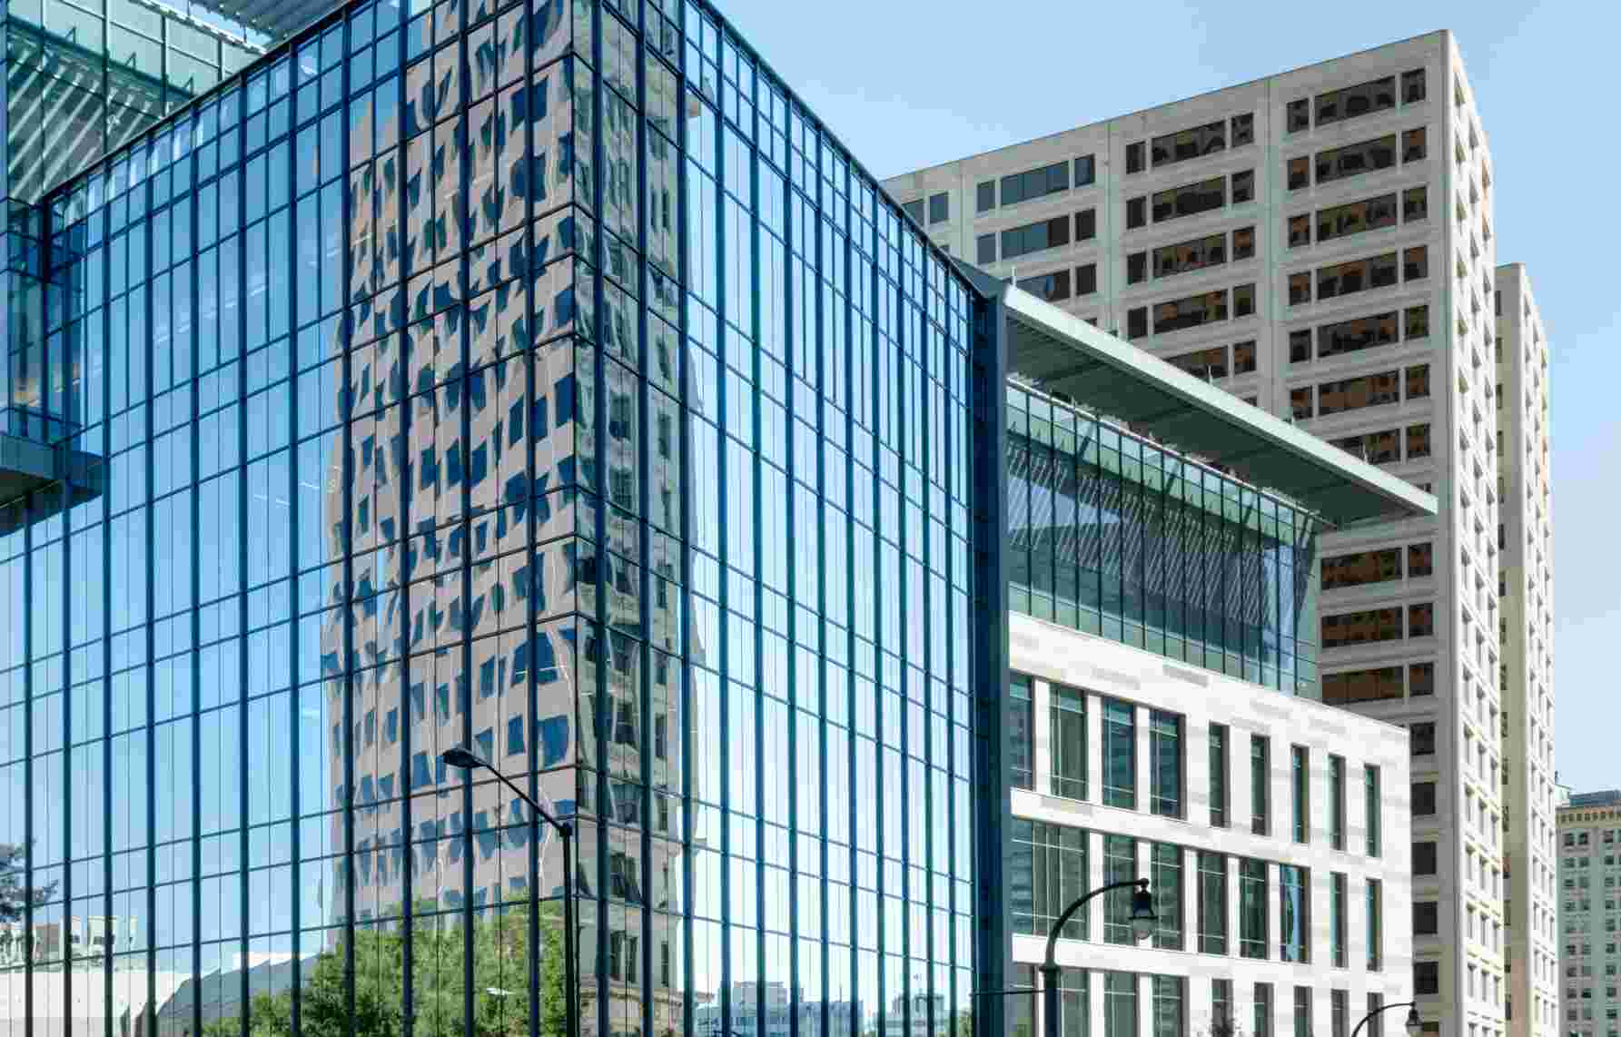
Picture credit:
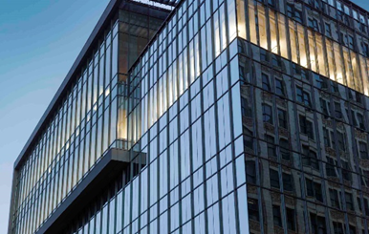
Vetrotech Saint-Gobain, Photo: Olaf Rohl

Press contact:
Rico Strüby
Vetrotech Saint-Gobain International AG
Bernstrasse 43 • 3175 Flamatt • Switzerland
rico.strueby@saint-gobain.com
Phone: +41 (0)31 336 81 14

About Vetrotech Saint-Gobain International AG:
Vetrotech Saint-Gobain International AG is part of the Saint-Gobain Group. Vetrotech specialises in the development, manufacture and distribution of high-performance safety glass for the building sector and for shipping. The focus is on offering multifunctional safety, comfort and design features for safe and seamless integration in buildings. Due to a wide range of fire-resistant, impact-resistant, attack-resistant, bulletproof, blast-resistant, pressure- and even hurricane-proof, high-security glass, we are in the position to offer innovative solutions even for the most demanding requirements. With seven production locations on three continents and approximately 840 employees worldwide, Vetrotech ensures that customers in over 60 countries can be reliably supplied by its sales offices, which are distributed around the entire world. More information about Vetrotech can be found at www.vetrotech.com or follow us on Twitter (@Vetrotech_Int).

About Saint-Gobain:
Saint-Gobain designs, manufactures and distributes materials and solutions which are key ingredients in the wellbeing of each of us and the future of all. They can be found everywhere in our living places and our daily life: in buildings, transportation, infrastructure and in many industrial applications. They provide comfort, performance and safety while addressing the challenges of sustainable construction, resource efficiency and climate change.

€40.8 billion in sales in 2017
Operates in 67 countries
More than 179,000 employees
www.saint-gobain.com
@saintgobain

